[Azure Doc extraction](https://learn.microsoft.com/en-us/azure/ai-services/document-intelligence/concept-custom-generative?view=doc-intel-4.0.0)

<https://learn.microsoft.com/en-us/azure/ai-services/document-intelligence/train/custom-generative-extraction?view=doc-intel-4.0.0>

[Prompt flow](https://learn.microsoft.com/en-us/azure/ai-studio/how-to/flow-develop)

<https://learn.microsoft.com/en-us/azure/ai-studio/how-to/flow-develop>

[Azure Gen AI based extraction](https://techcommunity.microsoft.com/t5/ai-azure-ai-services-blog/document-field-extraction-with-generative-ai/ba-p/4222950)

<https://techcommunity.microsoft.com/blog/azure-ai-services-blog/document-field-extraction-with-generative-ai/4222950>

[Prompt caching](https://www.anthropic.com/news/prompt-caching)

<https://www.anthropic.com/news/prompt-caching>

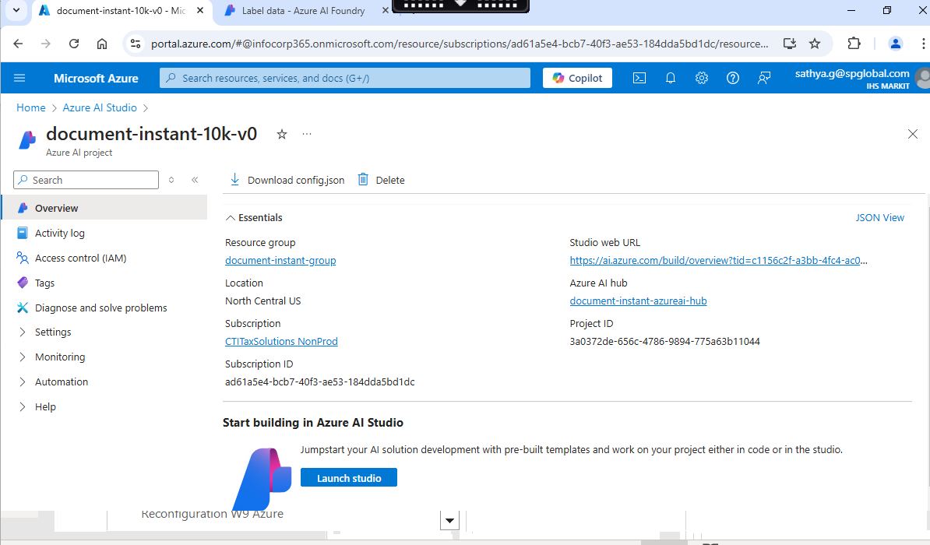

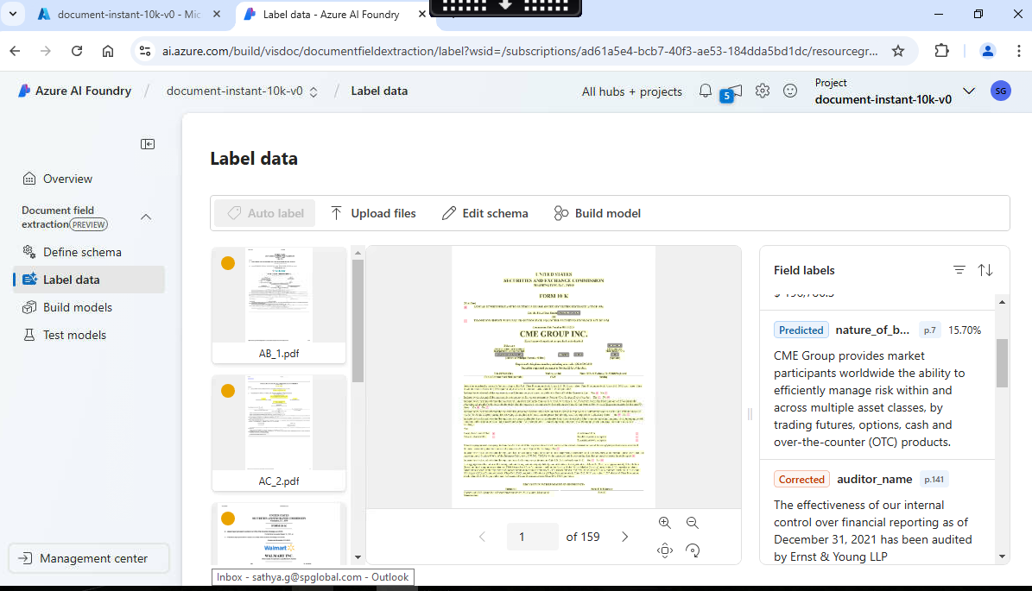

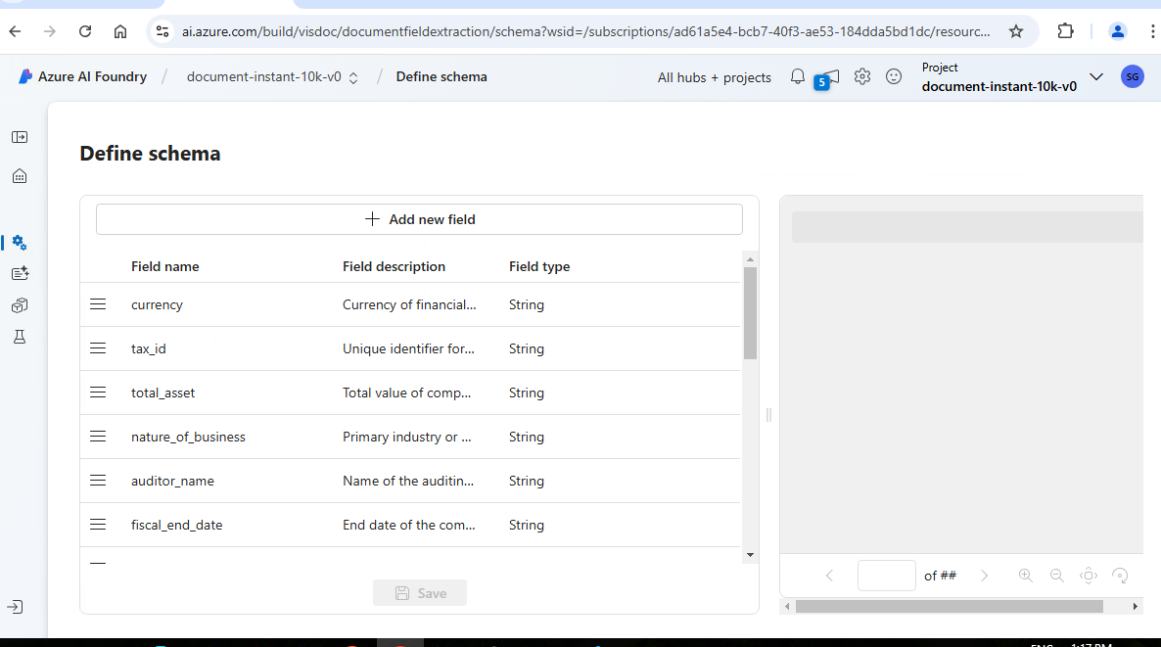

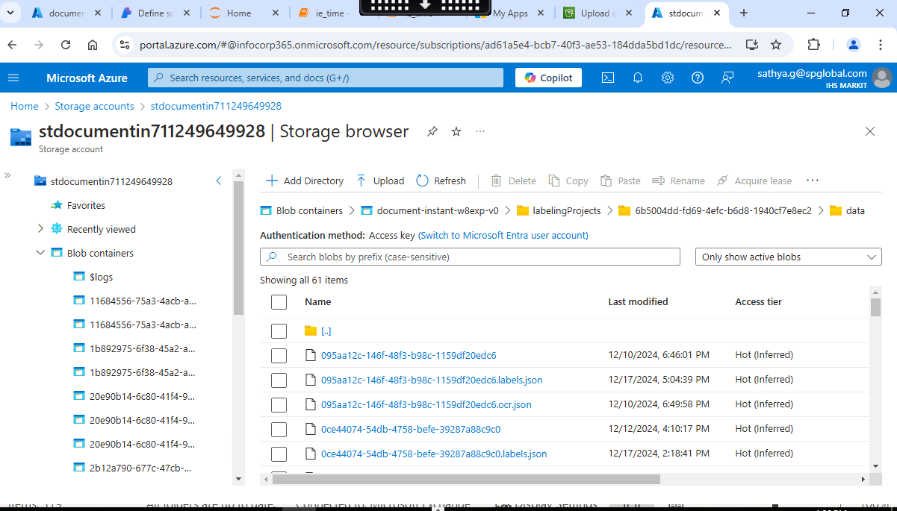

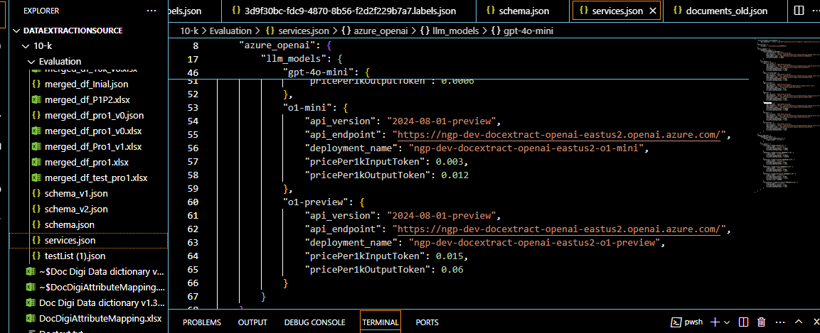

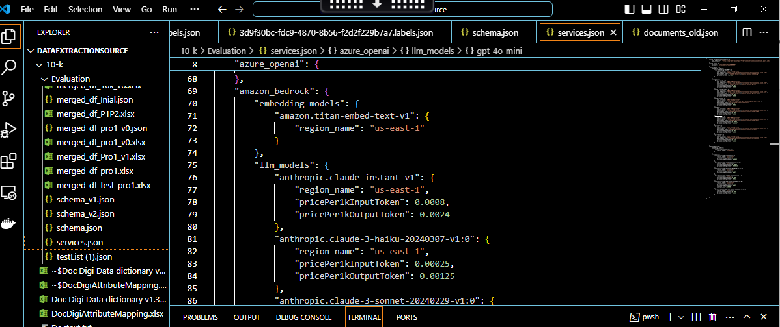

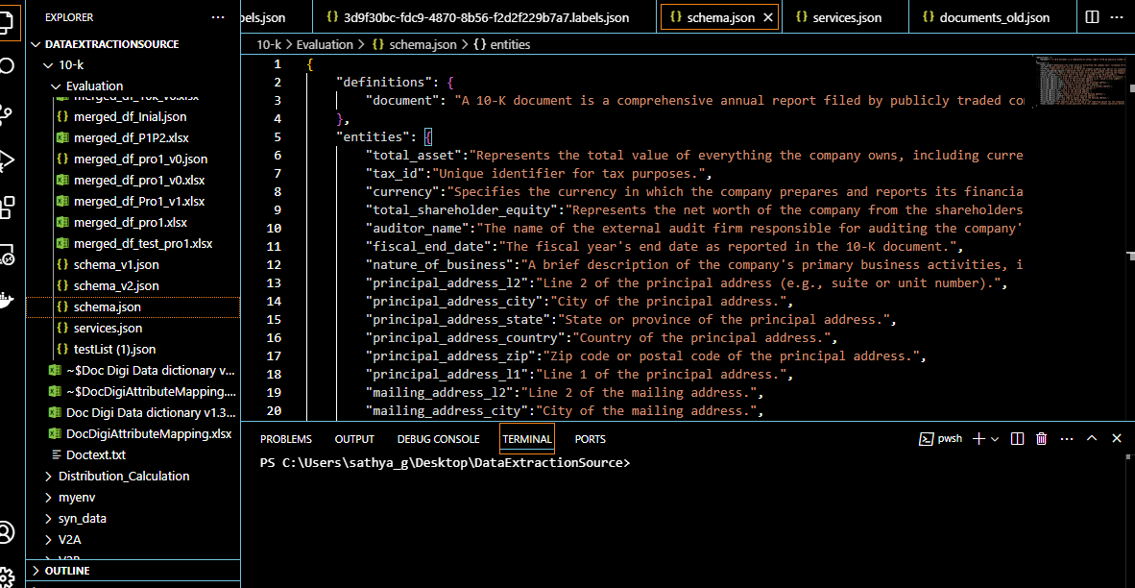

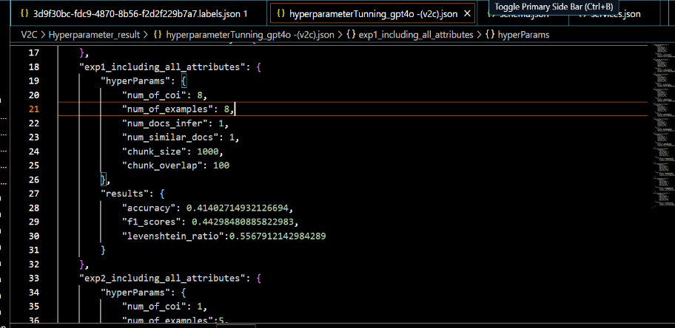

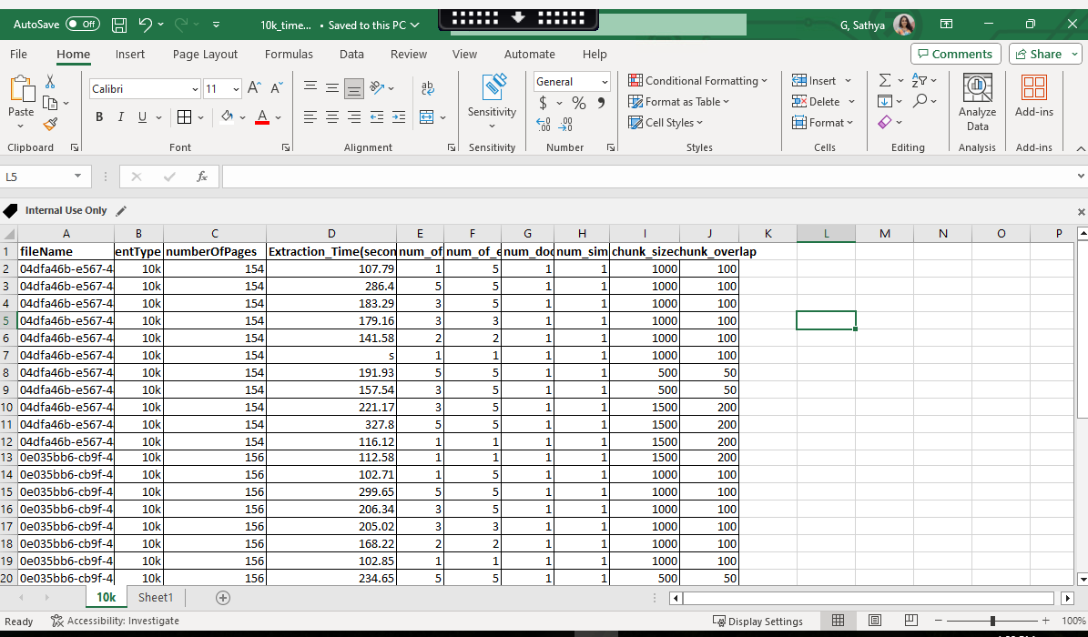

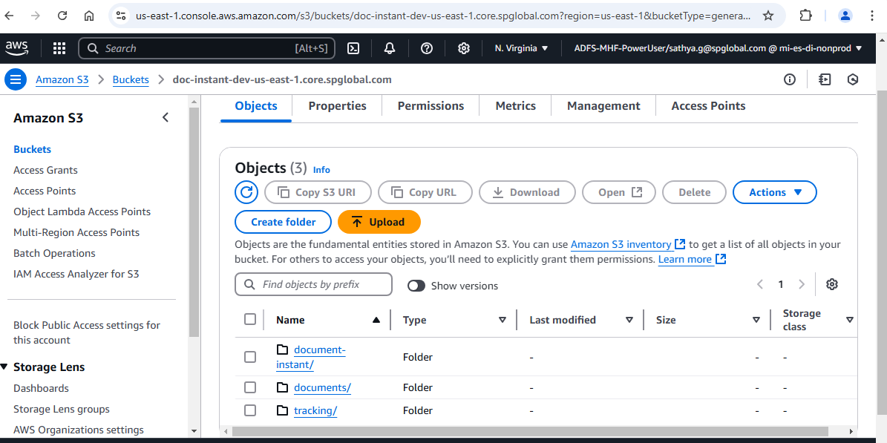

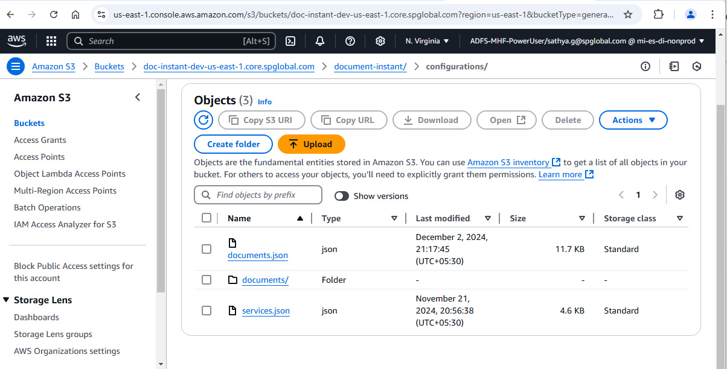

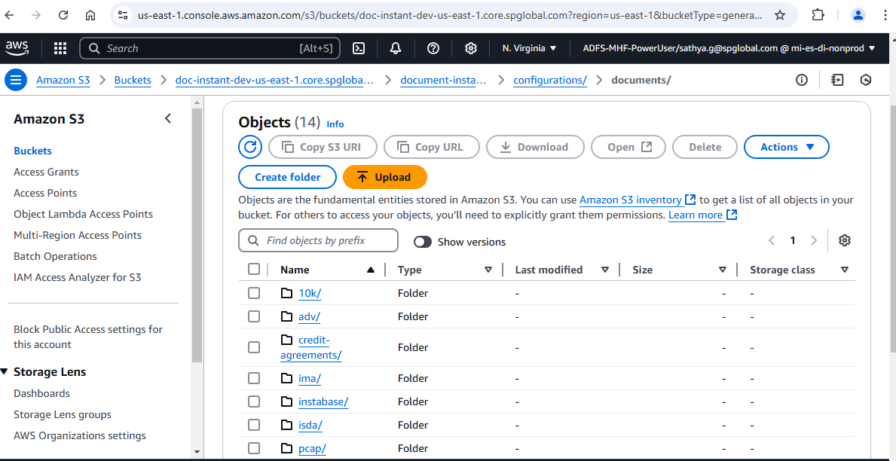

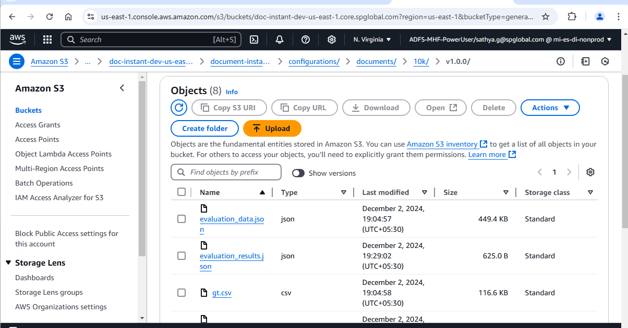

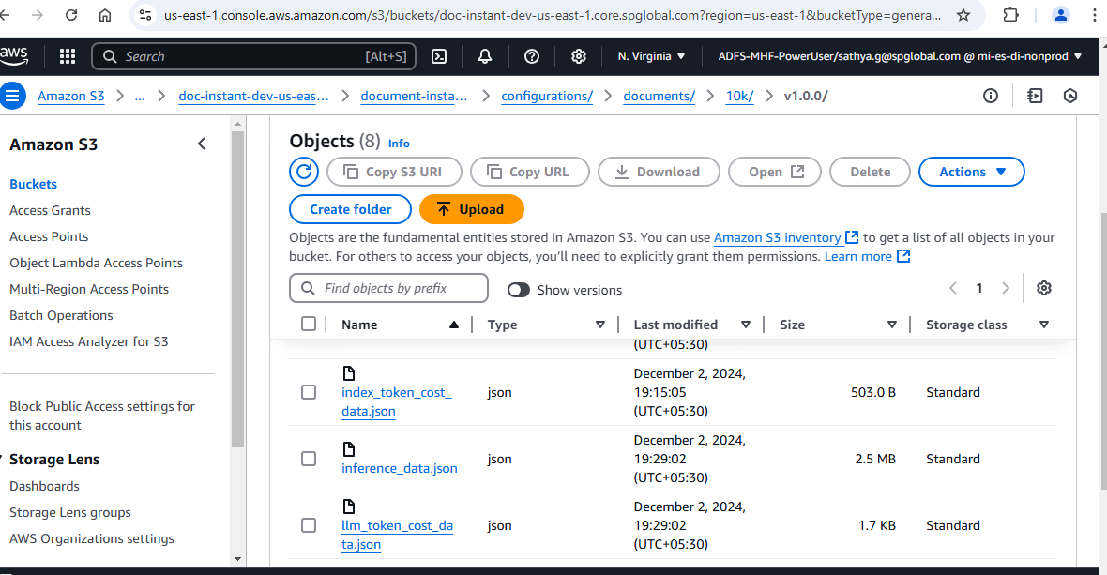

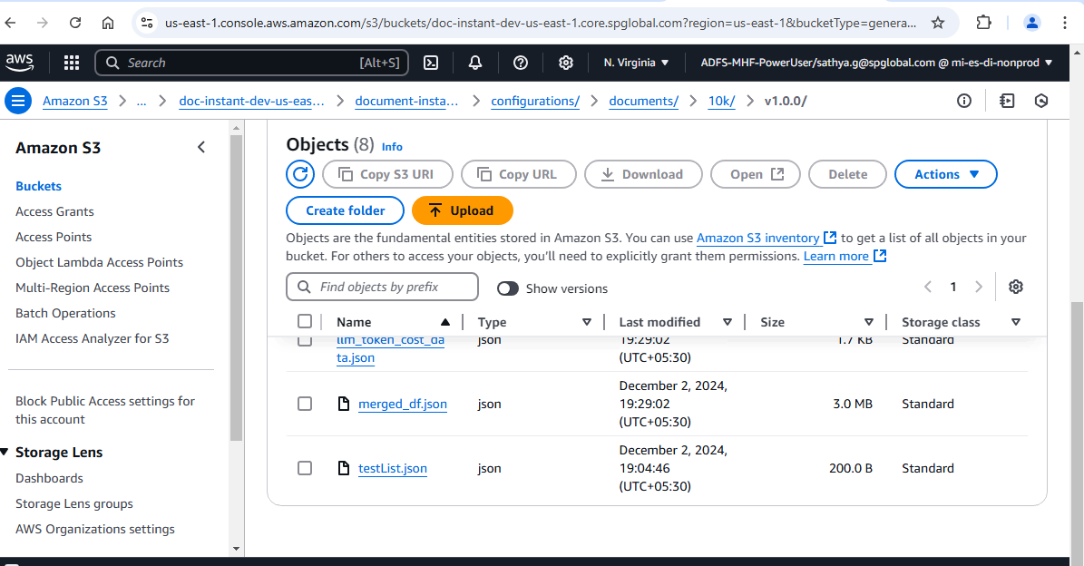

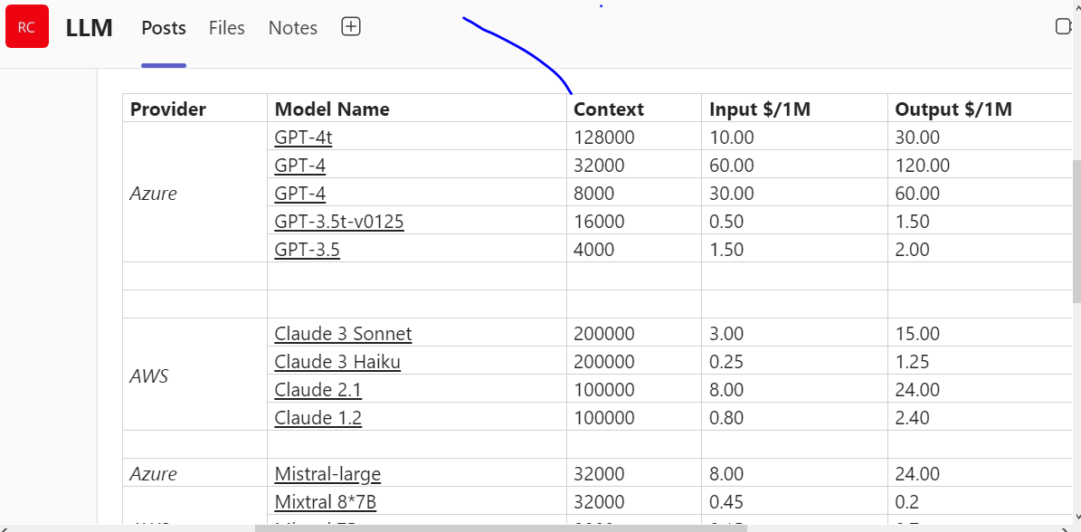

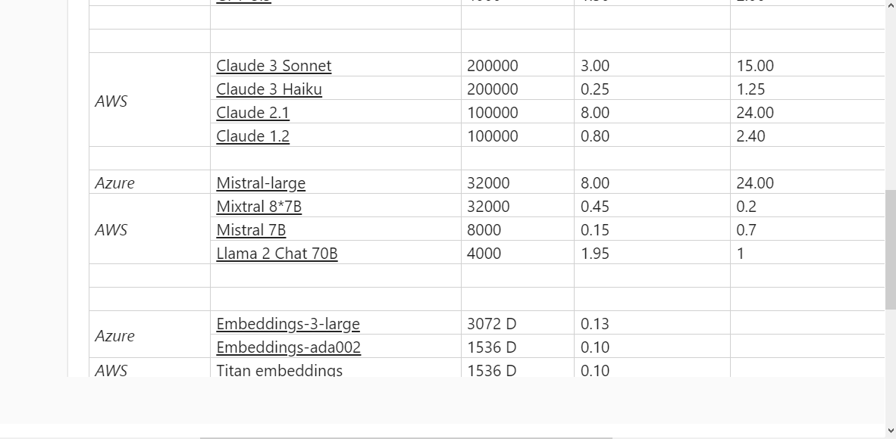

Requirement.txt

